DATA MANAGEMENT SYSTEM

2 DMS PROJECT PHASE – I SPECIFICATIONS
2.1 Graphical User Interface

Enabling functionalities for DMS
- Import data from VLog/CSV file to database,
- Export data from database to CSV file,
- Create new project details in the database,
- Displaying other parameters along with IR measurements in the graph page,
- Polishing DMS front end GUI,

- Import data
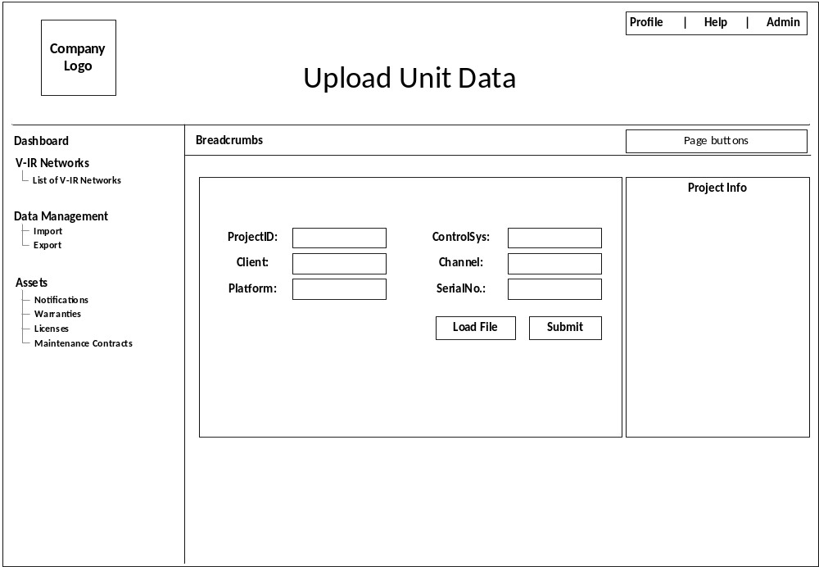
Figure 1: Import data page

Import data Page;
- Check for .CSV or .VLOG file.
  - If it’s CSV file upload directly to the database (It is not working).
  - If it’s VLOG file, convert into CSV format and upload the content and delete the converted CSV file if exists in the system.
- The conversion process source code will be provided.

2. Export unit data
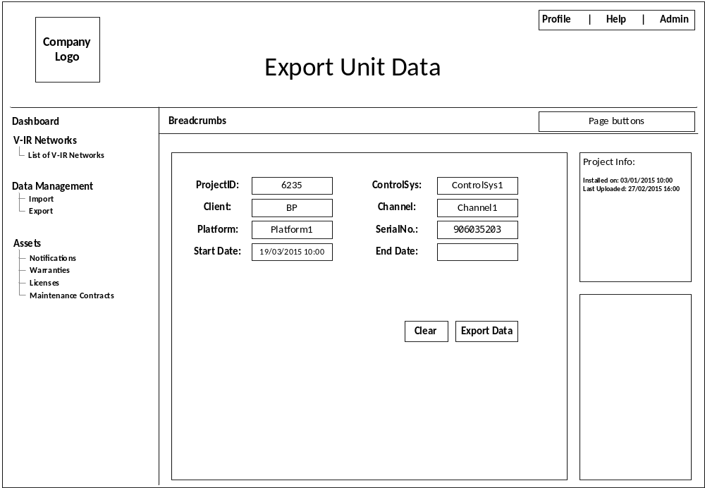
Figure 2: Export data page
Export data page;
- When export the data, should check for total length of the record, if length of the record is > 1,000,000 (1 million) split and store CSV file accordingly. (Excel limits to 1 million rows/records)
- Use DataTimePicker “Set options runtime DateTimePicker #” at http://xdsoft.net/jqplugins/datetimepicker/
- The output filename format is: “vlim-datalog_906035203<serialNumber>_2015-02-27<date>.csv”
- After selecting ProjectID, ControlSys, Client, Channel, corresponding available data’s start-date and end-date shall be shown in the “Project Info:” div so that when user make selection accordingly using DateTime picker.

3. Create project
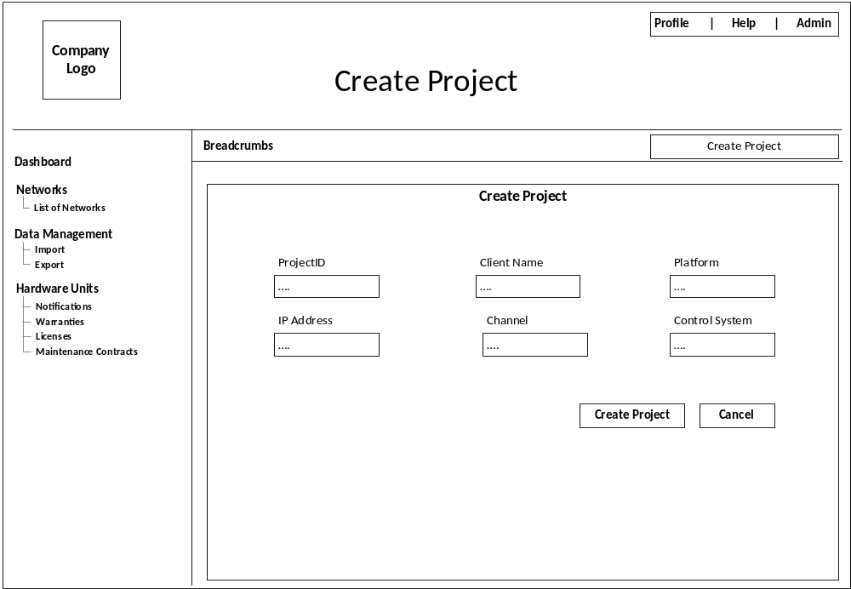
Figure 3: Create project page
Create project page;
- Reading project details from the user is in place.
- The project details should be pushed into the database

4. Detailed graphing
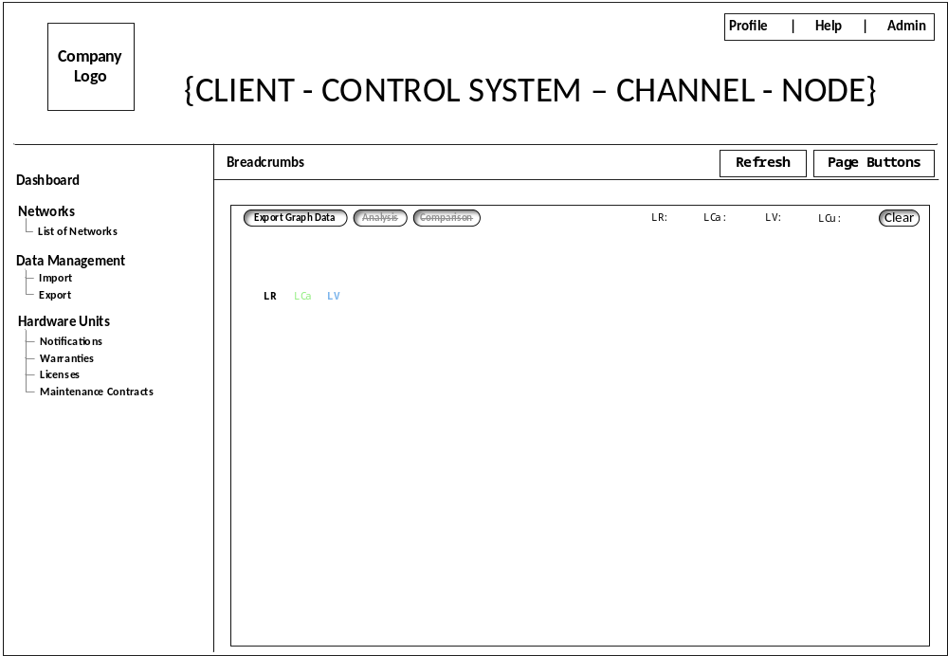
Figure 4: Graph page
Graph page;
- Remove the right side divs and bottom div to use full space for the graph.
- For testing use highstocks charts from highcharts.com.
- Other parameters such as LCa – ‘lim_capacitance_cm’, LV – ‘line_voltage’, LCu – ‘line_current’ shall be shown along with LR – ‘lim_resistance’ as soon as user clicks on appropriate check box.
- “Refresh” button shall refresh the graph page to default mode i.e, as soon as enter into graph page from Dashboard/network image page
- “Clear” button should clear the check boxes and goes to default mode
- “Export Graph Data” shall export the data of the present selection of the graph from the database in a CSV format.
- “Analysis” and “Comparison” buttons shall be present but not enabled.
- Name tag shall be displayed on top left of the graph page, each name tag should display same colour as the line graph (for ex; In graph line_voltage is shown in blue colour as the name ‘LV’ tag)

